**1.** (a) *p*(*A*  *B*) = 0.6 + 0.8 – 1 (M1)  
= 0.4 (A1) (C2)

(b) *p*(*A*  *B*) = *p*((*A*  *B*)) = 1 – 0.4 (M1)  
= 0.6 (A1) (C2)

[4]

**2.** (a) For attempting to use the formula (P(*E*  *F*) = P(*E*)P(*F*)) (M1)

Correct substitution or rearranging the formula A1

*eg*  P(*F*), P(*F*) = , P(*F*) = 

P(*F*) =  A1 N2

(b) For attempting to use the formula (P(*E*  *F*) = P(*E*) + P(*F*)  
− (P(*E*  *F*)) (M1)

P(*E*  *F*) =  A1

=  A1 N2

[6]

**3.** (a)  
 (A1) (C1)

(b) (i) *n*(*A*  *B*) = 2 (A1) (C1)

(ii) P(*A*  *B*) =  (allow **ft** from (b)(i)) (A1) (C1)

(c) *n*(*A*  *B*)  0 (or equivalent) (R1) (C1)

[4]

**4.** (a)  A1A1 N2

(b)  A1A1 N2

(c)  A2 N2

[6]

**5.** 2/13

**6.** 1/2

**7.** (a)

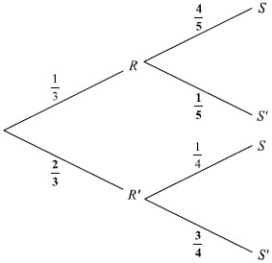

(A1)(A1)(A1)

(b) (i) P(*R  S*) =  (A1) (N1)

(ii) P(*S*) =  (A1)(A1)

=  (A1) (N3)

(iii) P(*R* *S*) =  (A1)(A1)

=  (A1) (N3)

[10]

**8.** (a)

 (A4) (C4)

(b) P (*G*  *W*) =  (A1)  
P(*NG*  *W*) =  (A1)  
P(*W*) =  (M1)  
=  (0.6875, 68.75% or 0.688 to 3 significant figures) (A1) (C4)